**Mastering Python Data Types: A Comprehensive Guide**

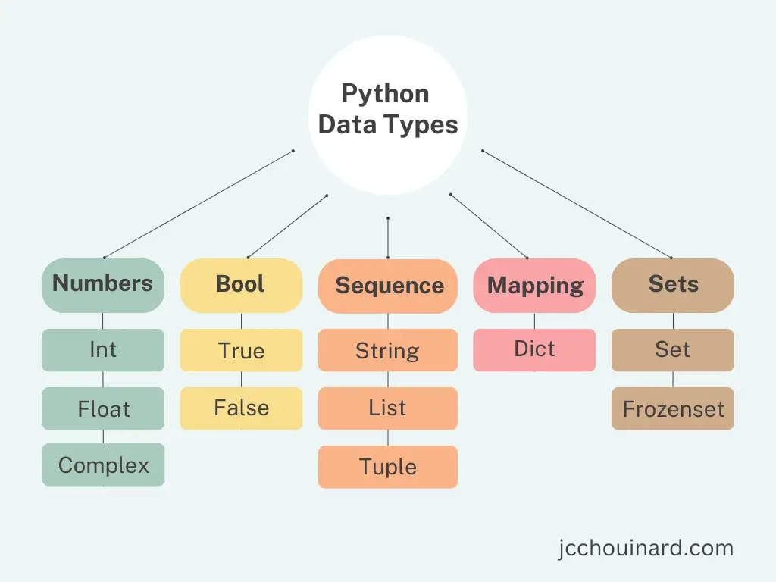

Data types serve as the foundation of any programming language, providing the essential framework for organizing and manipulating information. In Python, these data types play a crucial role in defining the nature of data and enabling various operations on them.

From simple numbers to complex structures, Python offers a diverse range of data types to accommodate different data formats and requirements.

In this guide, we'll unravel the mysteries of Python's data types, their applications, and practical implementations along the way.

1**. Numeric Data Types:**

* **Integers (`int`): I**ntegers represent whole numbers without decimal points, such as 10, -5, or 0.
* **Operations**: Integers support arithmetic operations such as addition (+), subtraction (-), multiplication (*), division (/), floor division (//), and exponentiation (**).
* **Conversions**: Integers can be converted to other numeric types like float and complex using constructors like **float() and complex().**

* **Floats (`float`)**: Floats represent real numbers with decimal points, such as 3.14, -0.001, or 2.5e-3 (scientific notation).

```

num_float = 3.14

print(num_float.is_integer()) # Output: False

print(num_float.hex()) # Output: '0x1.91eb851eb851fp+1'

```

* **Complex Numbers (`complex`)**: Complex numbers consist of a real part and an imaginary part, denoted as `a + bj`, where `a` is the real part and `b` is the imaginary part.

`**``python**

**# Example**

x = 10 # Integer

y = 3.14 # Float

z = 2 + 3j # Complex

num_complex = 2 + 3j

print(num_complex.real) # Output: 2.0

print(num_complex.imag) # Output: 3.0

```

* **Operations**: Complex numbers support arithmetic operations and can be added, subtracted, multiplied, divided, and exponentiated.
* **Conversions**: Complex numbers can be converted to other numeric types like float using constructors like float().

**2. Text Sequence Types:**

**Strings (`str`)**: Strings represent sequences of characters enclosed within single quotes, double quotes, or triple quotes.

**```python**

**# Example**

**#** string creations

name = 'Alice'

message = "Hello, World!"

paragraph = """Lorem ipsum dolor sit amet,

consectetur adipiscing elit."""

# String Concatenation

str1 = "Hello"

str2 = "World"

result = str1 + " " + str2

print(result) # Output: Hello World

# String Indexing and Slicing:

# String Methods:

# upper(), lower(), strip(), split(), replace()

# String Formatting:

name = "Alice"

age = 30

print("My name is %s and I am %d years old." % (name, age))

# Using format()

print("My name is {} and I am {} years old.".format(name, age))

# Using f-strings

print(f"My name is {name} and I am {age} years old.")

```

**3. Sequence Data Types:**

**Lists (`list`):** Lists represent ordered collections of elements, which can be of different data types and mutable (modifiable).

```

**# Example**

numbers = [1, 2, 3, 4, 5]

fruits = ['apple', 'banana', 'orange']

mixed = [1, 'hello', True]

```

**Tuples (`tuple`)**: Tuples are similar to lists but immutable (unchangeable). They are often used to store heterogeneous data.

```

# **Example**

point = (10, 20)

dimensions = (100, 200, 300)

```

**4. Mapping Data Types:**

**Dictionaries (`dict`):** Dictionaries represent collections of key-value pairs, allowing efficient retrieval of values based on keys.

```

**# Example**

person = {'name': 'Alice', 'age': 30, 'city': 'New York'}

```

Certainly! Let's explore the dictionary data type in Python:

### Dictionary Data Type:

In Python, a dictionary is a mutable, unordered collection of key-value pairs. Each key is unique and immutable, and it maps to a corresponding value. Dictionaries are enclosed in curly braces `{}`, and each key-value pair is separated by a colon `:`.

#### Example:

```python

# Creating a dictionary

student = {'name': 'John', 'age': 25, 'grade': 'A'}

```

### Key Characteristics:

1. **Mutable**: Dictionaries can be modified after creation. You can add, update, or remove key-value pairs.

2. **Unordered**: Unlike lists, dictionaries are unordered collections, meaning that the order of elements is not guaranteed.

3. **Keys are Unique**: Each key in a dictionary must be unique. If you attempt to add a duplicate key, the existing value will be overwritten.

4. **Keys are Immutable**: Dictionary keys must be immutable objects, such as strings, numbers, or tuples.

5. **Values Can Be Mutable**: Dictionary values can be of any data type and can be mutable or immutable.

### Common Operations and Methods:

#### 1. Accessing Elements:

You can access dictionary elements using square brackets `[]` with the key.

```python

# Accessing elements

print(student['name']) # Output: John

```

#### 2. Adding or Updating Elements:

To add a new key-value pair or update an existing value, simply assign the value to the key.

```python

# Adding a new key-value pair

student['grade'] = 'A'

# Updating an existing value

student['age'] = 26

```

#### 3. Removing Elements:

You can remove elements from a dictionary using the `del` keyword or the `pop()` method.

```python

# Removing a key-value pair

del student['grade']

# Removing and returning the value of a specific key

age = student.pop('age')

```

#### 4. Dictionary Methods:

- **`keys()`, `values()`, and `items()`**: Return views of the dictionary's keys, values, and key-value pairs, respectively.

- **`get(key, default)`**: Returns the value associated with the specified key. If the key is not found, it returns the default value (or `None` if not specified).

**5. Set Data Types:**

**Sets (`set`):** Sets represent unordered collections of unique elements, allowing set operations like union, intersection, and difference.

```

**# Example**

s1 = {1, 2, 3, 4, 5}

s2 = {3, 4, 5, 6, 7}

```

**Set Methods:**

- **`union()`**: Returns a new set containing all unique elements from both sets.

- **`intersection()`**: Returns a new set containing common elements between two sets.

- `**difference()`**: Returns a new set containing elements that are present in the first set but not in the second set.

- **`symmetric_difference()`**: Returns a new set containing elements that are present in either set, but not in both.

**Set Operations:**

- **Union (`|`)**: Combines elements from two sets, excluding duplicates.

- **Intersection (`&`)**: Returns elements common to both sets.

- **Difference (`-`)**: Returns elements present in the first set but not in the second.

- **Symmetric Difference (`^`)**: Returns elements present in either set, but not in both.

**6. Boolean Data Type:**

**Booleans (`bool`):** Booleans represent logical values `True` and `False`, often used in conditional statements and boolean operations.

```

**# Example**

is_raining = True

is_sunny = False

```

**7. NoneType:**

**None (`NoneType`):** `None` represents the absence of a value or a null value, often used to signify that a variable has no value assigned.

```

**# Example**

result = None

```

In short, Python offers a wide range of data types that make programming tasks easier. Understanding these types helps developers work with data effectively. Whether it's numbers, text, lists, dictionaries, or sets, Python has tools for every job. Mastering these tools unlocks Python's full potential, allowing developers to create powerful applications for various purposes like data analysis, machine learning, and web development.

By understanding and leveraging Python's data types effectively, developers can unlock the full potential of the language and embark on exciting journeys in data analysis, machine learning, web development, and beyond.